**SAFETY DATA SHEET** compiled according to Regulation (EC) No. 453/2010

**Compilation date:** 28/04/17 **Revision:** 1*

**1. Identification of the Substance/Preparation and of the Company/Undertaking**

**1.1. Product identifier**

Product form: Mixture

## Trade name : DETAN Tea and Coffee Stain Removal Powder

Product group : Trade product

Product code : **M4763**

**1.2. Relevant identified uses of the substance or mixture and uses advised against**

**1.2.1. Relevant identified uses**

Main use category : Professional use

Function or use category : Washing and cleaning products (including solvent based products).

**1.2.2. Uses advised against**

## No additional information available

## 1.3. Details of the supplier of the safety data sheet

**Company Name: Berwick Care Equipment Ltd**

**Lancaster Court, Lancaster Road**

**Harlescott Industrial Estate**

**Shrewsbury**

**SY1 3LG**

**Tel: 0845 38 111 38**

**2. Hazards Identification**

**2.1 Classification of the substance or mixture**

**2.1.1 Classification according to Regulation (EC) No. 1272/2008 [CLP]**

Eye Dam. 1: H318;

Skin Irrit. 2: H315

**2.2 Label Elements**

**Labelling according to Regulation (EC) No. 1272/2008 [CLP]**

Hazard Pictograms (CLP)

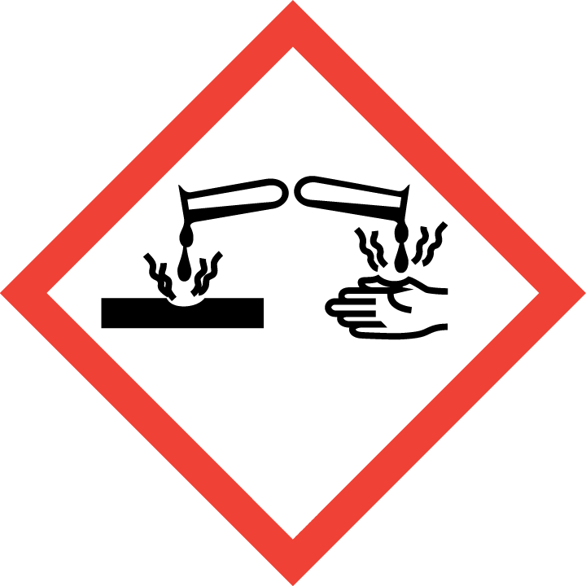

Signal word (CLP): Danger

Hazard Statements (CLP): H318: Causes serious eye damage.

H315: Causes skin irritation.

Precautionary Statements (CLP): P102 - Keep out of reach of children

P280 Wear protective gloves/protective clothing/eye protection/face protection.

P301+P330+P331 IF SWALLOWED: Rinse mouth. Do NOT induce vomiting.

P302 + P352 – IF ON SKIN: Wash with plenty of soap and water.

P332 + P313 – If skin irritation occurs: Get medical advice/attention.

P305+P351+P338 - IF IN EYES: Rinse cautiously with water for several minutes. Remove

contact lenses, if present and easy to do. Continue rinsing

P337+P313 - If eye irritation persists: Get medical advice/attention

The full texts for all H- and EUH-phrases are displayed in Section 16 ‘Other Information’.

**2.3 Other Hazards**

Other hazards not contributing

to the classification:No presence of PBT and vPvB ingredients.

**3. Composition/information on ingredients:**

**Common Name CAS No./ EC No. Classification Conc (%)**

**Accoding to (EC) 1272/2008 (CLP)**

SODIUM CARBONATE PEROXIDE 15630-89-4 Ox Sol. 3, H272 15 - 30

239-707-6 Acute Tox. 4, H302

Eye Dam. 1, H318

SODIUM SILICATE PENTAHYDRATE 6834-92-0 Skin Corr. 1B: H314 15 - 30

229-912-9 STOT SE3, H335

SODIUM CARBONATE 497-19-8 Eye Irrit. 2, H319 15 - 30

207-838-8

SODIUM C10-C12 BENZENE SULPHONATE 25155-30-0/ 68081-81-2 Acute Tox. 4 (Oral), H302 1 - 5

246-680-4 Skin Irrit. 2, H315

Eye Dam. 1, H318

STOT SE 3, H335

ALCOHOL ETHOXYLATE C14-15 PARETH-7EO 68951-67-7 Acute Tox. 4 (Oral), H302 1 - 5

Polymer Eye Dam. 1, H318

Aquatic Acute 1, H400

The full texts for all H- and EUH-phrases are displayed in Section 16 ‘Other Information’.

**4. First-aid measures**

**4.1. Description of first aid measures**

First-aid measures after inhalation : IF INHALED: remove victim to fresh air and keep at rest in a position comfortable for breathing. Seek medical advice if you feel unwell.

First-aid measures after skin contact : IF ON SKIN: Wash with plenty of soap and water. If skin irritation occurs: Get medical advice/attention, and discontinue use of product.

First-aid measures after eye contact : IF IN EYES: Rinse cautiously with water for several minutes. Remove contact lenses, if present and easy to do. Continue rinsing. If eye irritation persists, immediately call a doctor.

First-aid measures after ingestion : IF SWALLOWED: rinse mouth. Do NOT induce vomiting. Drink plenty of water. Seek medical advice if you feel unwell.

**4.2. Most important symptoms and effects, both acute and delayed**

Symptoms/injuries after inhalation : Coughing. sneezing.

Symptoms/injuries after skin contact : Redness. Swelling. dryness. Itching.

Symptoms/injuries after eye contact : Severe pain. Redness. Swelling. Blurred vision.

Symptoms/injuries after ingestion : Oral mucosal or gastro-intestinal irritation. Nausea. Vomiting. Excessive secretion. Diarrhoea.

**4.3. Indication of any immediate medical attention and special treatment needed**

Refer to section 4.1.

**SECTION 5: Firefighting measures**

**5. Fire fighting measures**

**Extinguishing media**: Product itself is not explosive or flammable. The product itself will not burn. If anything, packaging may be involved in a fire. Use CO2, dry chemical powder, alcohol resistant foam or other media appropriate for materials actually involved in the fire. If water is used, contain run-off.

**Special hazards:** When heated sufficiently, product may decompose to form smoke and toxic fumes.

**Special protective equipment:** Fire fighters should wear approved self-contained breathing apparatus and full protective clothing.

**6. Accidental release measures**

**Personal precautions:**

Avoid contact with skin and eyes. For appropriate personal protection see section 8.

**Environmental precautions:**

Although this product is suitable for down the drain disposal it is advised that as much of the solid is contained and scooped up, before final dispersal of any residue with water.

**Methods and material for containment and clean-up:**

Prevent leakage into sewers or surface water by utilising bunding, absorbent booms, drain covers and soil or sand dikes. Contact appropriate environmental protection agencies, (Environment Agency in the UK) and local water authorities if significant contamination occurs.

For small and large spills: scoop spillage into suitable plastic containers and rework/dispose as per local legislation.

**7. Handling and storage**

**Precautions for safe handling:**

Avoid contact with neat product on skin and eyes. Wear protective clothing as per section 8.

# Storage precautions:

Store in closed original container in a cool and dry area.

**8. Exposure controls / personal protection**

**8.1. Control parameters**

**Sodium Carbonate (CAS 497-19-8)**

**DNEL/PNEC Values**

DNEL/DMEL (Workers)

Long-term - local effects, inhalation 10 mg/m³

DNEL/DMEL (General population)

Acute - local effects, inhalation 10 mg/m³

**SODIUM PERCARBONATE (CAS 15630-89-4)**

**DNEL/PNEC Values**

Type Exposure Value Population Effect

DNEL Inhalation 5 mg/m3 Workers Local

DNEL Dermal 12.8 mg/cm2 Workers Local

DNEL Dermal 6.4 mg/cm2 Consumers Local

PNEC Environmental: Water 35 g/l - -

PNEC Environmental: STP 16 mg/l - -

**8.2. Exposure controls**

8.2.1. Appropriate engineering controls: Not applicable.

8.2.2. Personal protective equipment

Hand protection: Wear gloves during direct contact and hand-washing.

Eye protection: Wear eye/face protection.

Skin and body protection: Not applicable.

Respiratory protection: Not applicable.

**8.2.3. Environmental exposure controls:**

No particular measures required

**9. Physical and chemical properties**

Appearance: White powder

Odour: Non detectable

pH (10% aqueous solution) : ca. 11

Melting point: Not determined

Boiling point: Not determined

Flash point: Not combustible

Evaporation rate: Not determined

Flammability: Not combustible

Explosive properties: Non-Explosive

Oxidising properties: Not determined

Vapour pressure/density: Not determined

Relative density: ca. Not Determined

Water solubility: Soluble

Partition coefficient: Not determined

Auto ignition temperature: Not combustible

Decomposition temperature: Not determined

Viscosity: Not determined

**10. Stability and reactivity**

**Stability:**

Stable under normal conditions.

**Conditions to avoid:**

None

**Materials to avoid:**

Do not mix with other cleaning products unless advised to do so by a professional from the industry.

**11. Toxicological information**

**11.1 Information on toxicological effects**

**Acute Oral Toxicity:**

May cause burns in mucous membranes, throat, oesophagus and stomach.

**Acute Inhalation Toxicity:**

Dusts may irritate throat and respiratory system and cause coughing.

**Acute Dermal Toxicity:**

Irritating/ damaging to skin

**Skin Corrosion/Irritation:**

May cause chemical burns of the skin. Prolonged contact may cause tissue damage.

**Serious eye damage/eye irritation:**

Causes burns. Risk of corneal damage. Visual disturbances including blurred vision.

**Sensitisation:**

Not expected to provoke a sensitisation reaction.

**Repeated Dose Toxicity:**

Not data available.

**Assessment of STOT single exposure:** No data available

**Assessment of STOT repeated exposure:** No data available

**Risk of Aspiration Toxicity:** No data available

**Sodium Carbonate (CAS 497-19-8)**

LD50 oral rat 2800 mg/kg

LD50 dermal rabbit 2001 mg/kg

ATE CLP (oral) 2800 mg/kg bodyweight

ATE CLP (dermal) 2001 mg/kg bodyweight

**12. Ecological information**

On the basis of raw materials and comparable substances contained in the product the following ecologicalevaluation is obtained.

**Ecotoxicity:** This product is intended for wide dispersive use, is not considered harmful to aquatic organisms and is compatible with the down-the-drain disposal route. No known adverse effects on the functioning of water treatment plants under normal use

conditions as recommended. The product is not considered harmful to aquatic organisms nor to cause long-term adverse effects in the environment.

**Persistence and degradability:** This product has not been found to cause long-term adverse effects in the environment. The surfactants used in this product are biodegradable in line with the requirements of EU Detergent Regulation (EC) No 648/2004. Data to support this assertion are held at the disposal of the competent authorities of the Member States and will be made available to them, at their direct request or at the request of a detergent manufacturer.

**Bioaccumulative potential:** The surfactant ingredients of this product are not expected to bioaccumulate.

**Mobility in soil:** Not determined.

**13. Disposal considerations**

Consumer products ending up down the drain after use. Observe safe handling precautions and local legislation.

The product is not considered harmful to aquatic organisms nor to cause long-term adverse effects in the environment. The surfactants contained in this preparation comply with the biodegradability criteria as laid down in Regulation EC/648/2004 on detergents.

**14. Transport information**

**UN No:** None

**Classification:** Not classified as hazardous for transport.

**UN proper shipping name:** None

**Transport hazard class:** Not subject to ADR/IATA/IMDG/RID codes.

**Packing group:** None

**Environmental hazards:** None

**Special precautions for user:** None

**15. Regulatory information**

**15.1. Safety, health and environmental regulations/legislation specific for the substance or mixture**

**15.1.1. EU-Regulations**

No REACH Annex XVII restrictions. Contains no substance on the REACH candidate list

The surfactant(s) contained in this preparation complies(comply) with the biodegradability criteria as laid down in Regulation (EC) No.648/2004 on detergents. Data to support this assertion are held at the disposal of the competent authorities of the Member States and will be made available to them, at their direct request or at the request of a detergent manufacturer.

**15.1.2. National regulations**

No additional information available

**15.2. Chemical safety assessment**

No chemical safety assessment has been carried out

**16. Other information**

Usage and handling instructions are not mentioned on this Material Safety Data Sheet. The labelling of the product is indicated in Section 2.2.

The full text of the H- and EUH-phrases indicated in this safety data sheet are as follows:

Aquatic Acute 1: Acute aquatic toxicity, Category 1

Acute Tox. 4 (Oral): Acute toxicity (oral), Category 4

Eye Dam. 1: Serious eye damage/eye irritation, Category 1

Eye Irrit. 2: Serious eye damage/eye irritation, Category 2

Ox. Sol. 3: Oxidising Solids, Category 3

Skin Irrit. 2: Skin corrosion/irritation, Category 2

Skin Corr. 1: Skin corrosion, Category 1B

STOT SE 3: Specific target organ toxicity- single exposure, Category 3, Respiratory tract irritation

H272 May intensify fire; oxidiser

H302 Harmful if swallowed

H314 Causes severe skin burns and eye damage

H315 Causes skin irritation

H318 Causes serious eye damage

H319 Causes serious eye irritation

H335 May cause respiratory irritation

H400 Very toxic to aquatic life

The information given has been compiled with reference to the Chemicals (Hazard Information & Packaging For Supply) Regulations (CHIP4) 2009 as amended, the Registration, Evaluation, Authorisation & Restriction of Chemicals (REACH) Regulations, as amended, the Control of Substances Hazardous to Health Regulations (COSHH) 2002, as amended, and Regulation (EC) No 1272/2008 of the European Parliament and of the Council of 16 December 2008 on classification, labelling and packaging of substances and mixtures, amending and repealing Directives 67/548/EEC and 1999/45/EC, and amending Regulation (EC) No 1907/2006. This information also harmonises the provisions and criteria for the classification and labelling of substances, mixtures and certain specific articles within the Community, taking into account the classification criteria and labelling rules of the GHS.

**Legal disclaimer:** The above information is believed to be correct but does not purport to be all inclusive and shall be used only as a guide. This company shall not be held liable for any damage resulting from handling or from contact with the above product.