SAFETY DATA SHEET compiled according to Regulation (EC) No. 453/2010
Compilation date: 09/08/18 Revision [CLP]: 1*

1. Identification of the Substance/Preparation and of the Company/Undertaking
1.1. Product identifier
Product form: Mixture

Trade name: Gleemx Glint Machine Detergent (Blue Label)
Product group: Trade product
Product code: M4759/ M4756

1.2. Relevant identified uses of the substance or mixture and uses advised against
1.2.1. Relevant identified uses
Main use category: Professional use
Function or use category: Washing and cleaning products (including solvent based products).
A commercial quality non-foaming automatic dishwasher liquid, formulated to remove all food soiling. Recommended to use only in medium to soft water hardness areas.

1.2.2. Uses advised against

No additional information available

1.3. Details of the supplier of the safety data sheet

Company Name: Berwick Care Equipment Ltd
Lancaster Court, Lancaster Road
Harlescott Industrial Estate
Shrewsbury
SY1 3LG
Tel: 0845 38 111 38
Email: sales@berwickcare.co.uk

2. Hazards Identification
2.1 Classification of the substance or mixture
2.1.1 Classification according to Regulation (EC) No. 1272/2008 [CLP]
Skin Corr. 1A, Eye Dam. 1: H314

2.2 Label Elements
Labelling according to Regulation (EC) No. 1272/2008 [CLP]
Hazard Pictograms (CLP)
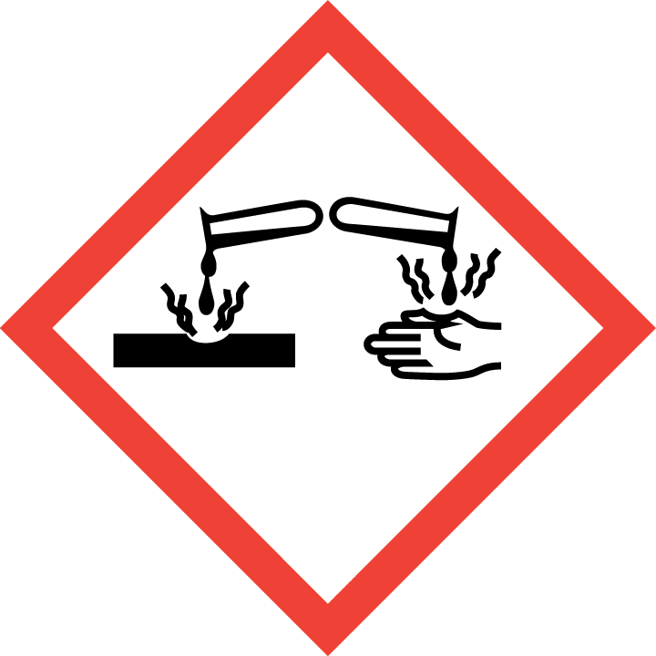
Signal word (CLP): Danger.
Hazard statements (CLP): H314 Causes severe skin burns and eye damage.

Precautionary statements (CLP): P102 Keep out of reach of children.
P260 Do not breathe mist.
P280 Wear protective gloves/protective clothing/eye protection/face protection.
P301+P330+P331 IF SWALLOWED: Rinse mouth. Do NOT induce vomiting.
P303+P361+P353 IF ON SKIN (or hair): Take off immediately all contaminated clothing. Rinse
skin with water/shower.
P304+P340 IF INHALED: Remove person to fresh air and keep comfortable for breathing.
P305+P351+P338 IF IN EYES: Rinse cautiously with water for several minutes. Remove
contact lenses, if present and easy to do. Continue rinsing.
P315 Get immediate medical advice/attention.

The full texts for all H- and EUH-phrases are displayed in Section 16 ‘Other Information’.

2.3 Other Hazards

See also section 10
No presence of PBT and vPvB ingredients.

3. Composition/information on ingredients:

Common Name CAS No./ EC No. Classification Conc (%)
Accoding to (EC) 1272/2008 (CLP)
SODIUM HYDROXIDE 1310-73-2 Met. Corr. 1, H290 5 - 15
215-185-5 Skin Corr. 1A, H314

TETRASODIUM ETHYLENDIAMINE 64-02-8 Acute Tox. 4, H302 1 - 5
TETRAACETATE 200-573-9 Acute Tox. 4, H332
Eye Dam. 1, H318

TRISODIUM NITRILOTRIACETATE 5064-31-3 Acute Tox. 4, H302 1 - 5
225-768-6 Eye Irrit. 2, H319
Carc. 2, H351

The full texts for all H- and EUH-phrases are displayed in Section 16 ‘Other Information’.

4. First-aid measures
4.1. Description of first aid measures
First-aid measures after inhalation: IF INHALED: Unlikely route of exposure as the product does not contain volatile substances. If spray/mist has been inhaled, move affected person to fresh air and keep warm and at rest in a position comfortable for breathing.
First-aid measures after skin contact: IF ON SKIN: Wash with plenty of water. If skin irritation occurs: Get medical advice/attention immediately.
First-aid measures after eye contact: IF IN EYES: Rinse cautiously with water for at least 10 minutes. Remove contact lenses, if present and easy to do. Continue rinsing. Consult an ophthalmologist immediately if the symptoms persist. When dealing with caustic substances, notify emergency physician immediately (key words: burn in the eye). Immediately call a doctor.
First-aid measures after ingestion: IF SWALLOWED: rinse mouth. Drink plenty of water. Do NOT induce vomiting. Immediately call a doctor.

4.2. Most important symptoms and effects, both acute and delayed
Symptoms/injuries after inhalation: Irritation of nose, throat and airway.
Symptoms/injuries after skin contact: Burning pain and severe corrosive skin damage. May cause serious chemical burns to the skin.
Symptoms/injuries after eye contact: Severe irritation, burning and tearing. Prolonged contact causes serious eye and tissue damage.
Symptoms/injuries after ingestion: May cause chemical burns in mouth and throat.

4.3. Indication of any immediate medical attention and special treatment needed
Treat symptomatically.
SECTION 5: Firefighting measures
5. Fire fighting measures
Extinguishing media: The product is not flammable. Use fire-extinguishing media suitable for the surrounding fire.
Special hazards: Thermal decomposition or combustion products may include the following substances: Irritating gases or vapours.
Special protective equipment: Wear positive-pressure self-contained breathing apparatus (SCBA) and appropriate protective clothing.

6. Accidental release measures
Personal precautions:
Product causes chemical burns. Wear personal protection, see Section 8
Evacuate personnel to safe areas. Keep out unprotected personnel. Keep unauthorised personnel away
Environmental precautions:
Observe regulations on prevention of water pollution. Dam with sand or earth or appropriate bunding.
Do not permit to enter into surface water, stretches of water or soil undiluted.
Spillages or uncontrolled discharges into watercourses must be reported immediately to the Environmental Agency or other
appropriate regulatory body.
Methods and material for containment and clean-up:
Small Spillages: Flush away spillage with plenty of water. Large Spillages: Contain and absorb spillage with sand, earth or other
non-combustible material. Collect and place in suitable waste disposal containers and seal securely.
Additional advice:
See Section 8.

7. Handling and storage
Precautions for safe handling:
Handle in accordance with good industrial hygiene and safety practices.
Wear protective clothing, gloves, eye and face protection. For personal protection see section 8.

Storage precautions:
Keep only in the original container in a cool, well-ventilated place. Store away from the following materials: Oxidising materials.
Advice on common storage
Do not store together with: oxidising substances
Do not store together with: acidic substances

8. Exposure controls / personal protection
8.1. Control parameters
SODIUM HYDROXIDE
Workplace exposure limits:
Short-term exposure limit (15-minute): WEL 2 mg/m3
WEL = Workplace Exposure Limit

DNEL/DMEL (Workers)
Long-term - local effects, inhalation 1.5 mg/m³
DNEL/DMEL (General population)
Acute - local effects, inhalation 2.5 mg/m³
PNEC values
Freshwater
Value 2.2 mg/l
Marine water
Value 0.22 mg/l
STP
Value 43 mg/l
Soil
Value 0.72 mg/ kg

Ingredients Comments: No exposure limits noted for ingredients.

8.2. Exposure controls
Engineering measures: It is advisable to provide for installation of emergency shower and eye bath. Provide adequate ventilation.
Respiratory protection: If workplace exposure limit is exceeded apply Respiratory protective equipment.
Hand protection: Wear suitable gloves. PVC or rubber gloves are recommended.
Eye protection: Wear approved safety goggles or face shield.
Skin protection: Wear protective clothing, against splashing and contamination.
Hygiene Measures: Do not inhale vapour, aerosols, mist. Avoid contact with skin, eyes and clothing. Ensure there is good room ventilation. No eating, drinking, smoking or snuffing tobacco at work. Wash face and/or hands before breaks and end of work
Use preventative skin protection. Avoid contaminating clothes with product. Immediately change moistened and saturated work clothing. Any contaminated protective equipment to be cleaned after use.
Protective Measures: Handle in accordance with good industrial hygiene and safety practices. Wear suitable protective clothing, gloves and eye/face protection.

9. Physical and chemical properties

Appearance Liquid.
Colour Colourless. to Pale straw.
Odour Not defined
pH pH (diluted solution): 11.60 @ 3ml / Litre
Melting point Data not available
Initial boiling point and range 102°C @ 760 mm Hg
Flash point Boils without flashing.
Relative density 1.197 @ 20°C
Solubility Soluble in water.

9.2 Further information
Miscibility in water: Completely miscible
Other information: Corrosive, alkaline agent

10. Stability and reactivity
10.1 Reactivity
Reactions with the following materials may generate heat: Strong acids and Oxidising agents.
10.2 Chemical stability
Stable under recommended storage conditions
10.3 Possibility of hazardous reactions
See Sections 10.1, 10.2 and 10.5
10.4 Conditions to avoid
Strong Heat.
10.5 Incompatible materials
Strong acids and Oxidising agents. Aluminium, Tin, Zinc and their alloys. Do not mix with other cleaning products unless advised to do so by a professional from the industry.
10.6 Hazardous decomposition products
Decomposition products under conditions of thermal decomposition: unknown

11. Toxicological information
11.1 Information on toxicological effects
Acute Oral Toxicity:
May cause burns in mucous membranes, throat, oesophagus and stomach. Causes burns.
Acute Inhalation Toxicity:
Vapours may irritate throat and respiratory system and cause coughing.
Acute Dermal Toxicity:
Irritating/ damaging to skin
Skin Corrosion/Irritation:
May cause serious chemical burns of the skin. Corrosive. Prolonged contact causes serious tissue damage.
Serious eye damage/eye irritation:
Causes burns. Risk of corneal damage. Visual disturbances including blurred vision.
Sensitisation:
Not known to be sensitising.
Repeated Dose Toxicity:
Not data available.
Assessment of STOT single exposure: No data available
Assessment of STOT repeated exposure: No data available
Risk of Aspiration Toxicity: No data available

12. Ecological information
12.1 Persistence and degradability
Ecological hazards relating to alkalinity of the product
Bio accumulative potential:
Bioaccumulation: none.
12.2 Ecotoxicity effects
Toxicity to fish:
Not considered to be toxic to fish
12.3 Results of PBT and vPvB assessment:
Not a PBT, vPvB substance as per the criteria of the REACH Ordinance.
Further information on ecology:
AOX: The product does not contain any organically bonded halogen.
Ecotoxicity Assessment:
Acute Aquatic toxicity: The classification criteria are not met based on the available data. The product components are not classified as environmentally hazardous. However, this does not exclude the possibility that large or frequent spills can have a harmful or damaging effect on the environment.

13. Disposal considerations
13.1 Waste treatment methods
Product: Disposal in accordance to local authority regulations. In the case of recycling/disposal contact the relevant authorities. Offer surplus and non-recyclable solutions to a licensed disposal company.
With small amounts: May be disposed of as sewage water in accordance with local regulations by previously diluting with plenty of water.
Uncleaned Packaging: Rinse empty containers before disposal; recommended cleaning agent; water.
Offer rinsed packaging material to local recycling facilities. Do not use empty containers and dispose of in accordance with the regulations issued by the appropriate local authorities. Dispose of containers that have not been emptied completely and/or
cleaned, in the same manner as the substance.

14. Transport information
Land Transport ADR/RID/GGVSEB (Germany)
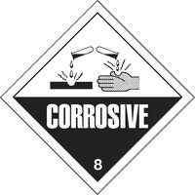
ADR/RID – Labels Corrosive, 8
Class 8
UN No. 1824
Packaging group II
Tunnel Restriction Code (ADR) (E)
Description of the goods (technical name) Sodium Hydroxide Solution

Sea Transport IMDG-Code/GGVSee (Germany)
Class 8
Subsidiary risk
UN No. 1824
EmS F-A, S-B
Packaging group II
Proper technical name (proper shipping name) Sodium hydroxide, Aqueous solution

15. Regulatory information
15.1. Safety, health and environmental regulations/legislation specific for the substance or mixture
15.1.1. EU-Regulations
No REACH Annex XVII restrictions. Contains no substance on the REACH candidate list
Where applicable, the surfactant(s) contained in this preparation complies (comply) with the biodegradability criteria as laid down in Regulation (EC) No.648/2004 on detergents. Data to support this assertion are held at the disposal of the competent authorities of the Member States and will be made available to them, at their direct request or at the request of a detergent manufacturer.

15.1.2. National regulations
No additional information available

15.2. Chemical safety assessment
No chemical safety assessment has been carried out

16. Other information
Usage and handling instructions are not mentioned on this Material Safety Data Sheet. The labelling of the product is indicated in Section 2.2.

The full text of the H- and EUH-phrases indicated in this safety data sheet are as follows:

H290: May be corrosive to metals.
H302: Harmful if swallowed
H314: Causes severe skin burns and eye damage.
H318: Causes serious eye damage
H332: Harmful if inhaled
H351: Suspected of causing cancer

The information given has been compiled with reference to the Chemicals (Hazard Information & Packaging For Supply) Regulations (CHIP4) 2009 as amended, the Registration, Evaluation, Authorisation & Restriction of Chemicals (REACH) Regulations, as amended, the Control of Substances Hazardous to Health Regulations (COSHH) 2002, as amended, and Regulation (EC) No 1272/2008 of the European Parliament and of the Council of 16 December 2008 on classification, labelling and packaging of substances and mixtures, amending and repealing Directives 67/548/EEC and 1999/45/EC, and amending Regulation (EC) No 1907/2006. This information also harmonises the provisions and criteria for the classification and labelling of substances, mixtures and certain specific articles within the Community, taking into account the classification criteria and labelling rules of the GHS.

Legal disclaimer: The above information is believed to be correct but does not purport to be all inclusive and shall be used only as a guide. This company shall not be held liable for any damage resulting from handling or from contact with the above product.

